Lesson 1 react hooks and context

<https://www.youtube.com/watch?v=6RhOzQciVwI&list=PL4cUxeGkcC9hNokByJilPg5g9m2APUePI>

With the react context API share state don’t have to pass props around .  
Hooks can do stuff in functional components that previously could only do inside class components - like use state or tap into a lifecycle metond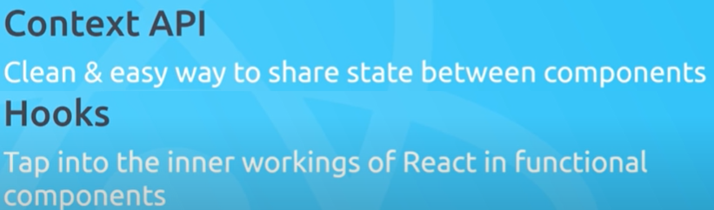

Using together can work with shared data inside app similar to redux without having the lift of redux

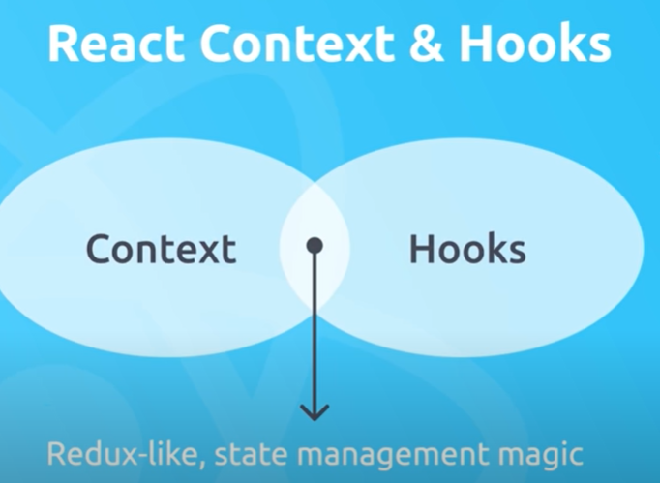

Project Making a reading in local storage

After creating using npx, can clean up files

Starting off creating them as class components

